**Question 1:**

**Part 1:**

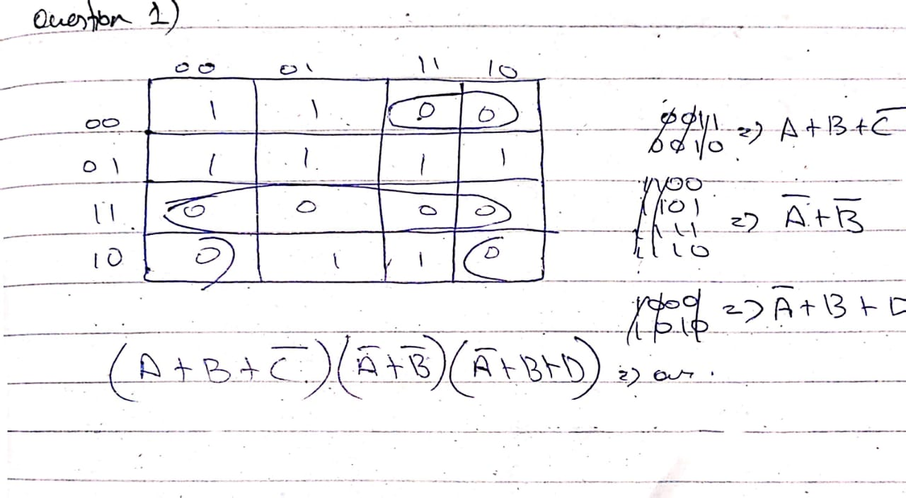

**Part 2:**

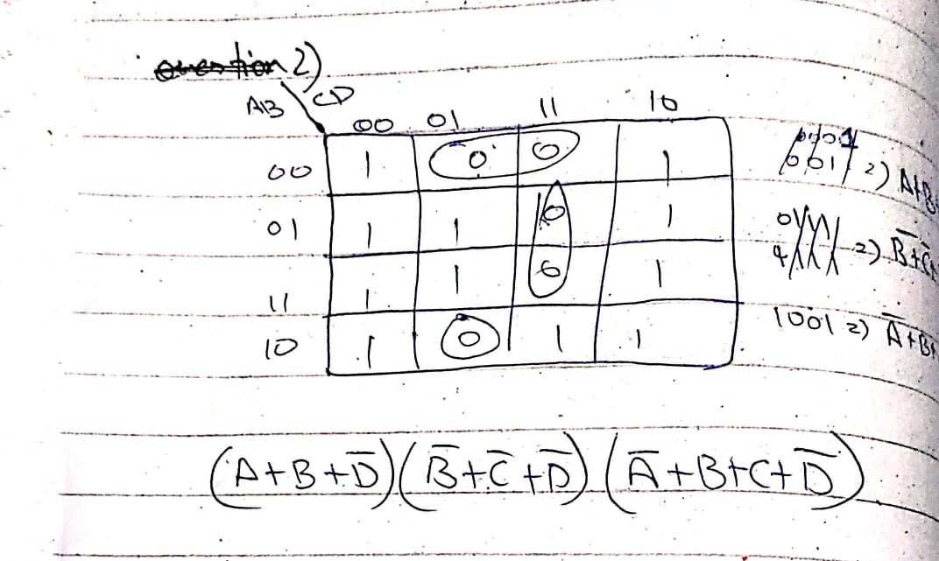

**Question 2:**

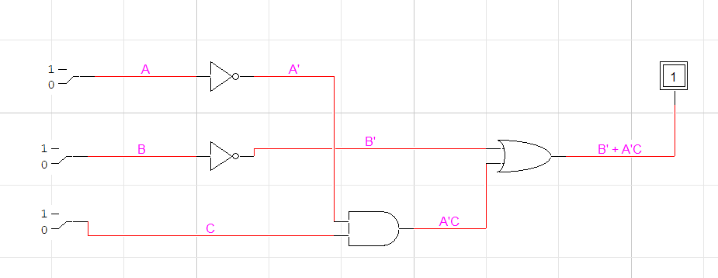

**Equations:**

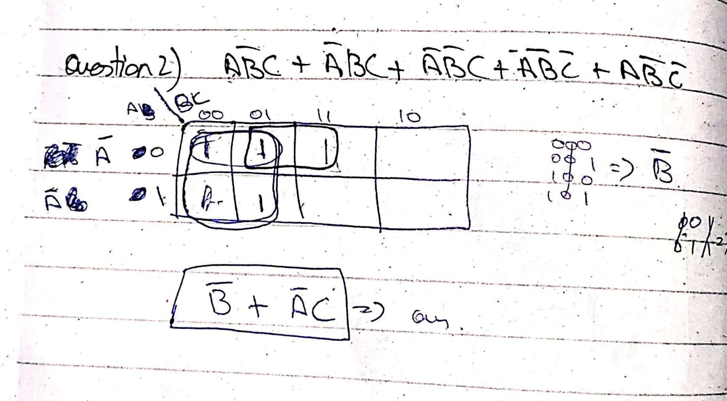

**Truth Tables:**

|  |  |  |  |
| --- | --- | --- | --- |
| A | B | C | X |
| 0 | **0** | **0** | **1** |
| 0 | **0** | **1** | **1** |
| 0 | **1** | **0** | **0** |
| 0 | **1** | **1** | **1** |
| 1 | **0** | **0** | **1** |
| 1 | **0** | **1** | **1** |
| 1 | **1** | **0** | **0** |
| 1 | **1** | **1** | **0** |

**Question 3:**

**SOP:**

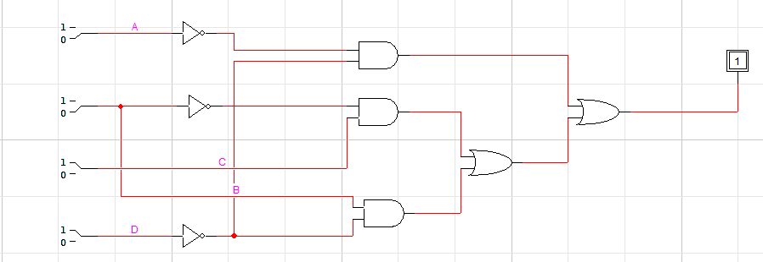

**Truth Table SOP:**

|  |  |  |  |  |
| --- | --- | --- | --- | --- |
| A | B | C | D | X |
| 0 | **0** | **0** | **0** | **1** |
| 0 | **0** | **0** | **1** | **0** |
| 0 | **0** | **1** | **0** | **1** |
| 0 | **0** | **1** | **1** | **1** |
| 0 | **1** | **0** | **0** | **1** |
| 0 | **1** | **0** | **1** | **0** |
| 0 | **1** | **1** | **0** | **1** |
| 0 | **1** | **1** | **1** | **0** |
| 1 | **0** | **0** | **0** | **0** |
| 1 | **0** | **0** | **1** | **0** |
| 1 | **0** | **1** | **0** | **1** |
| 1 | **0** | **1** | **1** | **1** |
| 1 | **1** | **0** | **0** | **1** |
| 1 | **1** | **0** | **1** | **0** |
| 1 | **1** | **1** | **0** | **1** |
| 1 | **1** | **1** | **1** | **0** |

**POS:**

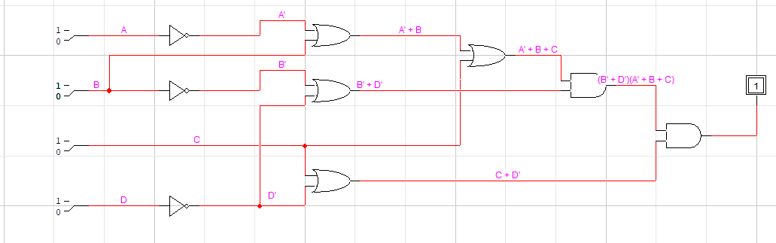

**Truth Table POS:**

|  |  |  |  |  |
| --- | --- | --- | --- | --- |
| A | B | C | D | X |
| 0 | **0** | **0** | **0** | **1** |
| 0 | **0** | **0** | **1** | **0** |
| 0 | **0** | **1** | **0** | **1** |
| 0 | **0** | **1** | **1** | **1** |
| 0 | **1** | **0** | **0** | **1** |
| 0 | **1** | **0** | **1** | **0** |
| 0 | **1** | **1** | **0** | **1** |
| 0 | **1** | **1** | **1** | **0** |
| 1 | **0** | **0** | **0** | **0** |
| 1 | **0** | **0** | **1** | **0** |
| 1 | **0** | **1** | **0** | **1** |
| 1 | **0** | **1** | **1** | **1** |
| 1 | **1** | **0** | **0** | **1** |
| 1 | **1** | **0** | **1** | **0** |
| 1 | **1** | **1** | **0** | **1** |
| 1 | **1** | **1** | **1** | **0** |

**Equation SOP And POS:**

